SAP - Apache Mail Service

Detailed Design Specification

Author: Praveen D
Creation Date: 15th April, 2013
Last Updated:

Revision History
Date | Description | Author/Review | Version
15-Apr-2013 | Initial draft | Praveen D | 1.0
13-May-2013 | Added the design changes | Praveen D | 1.1

Related Documents
Date | Version | Document Name | Description
NA | NA | NA | NA

Table of Contents

1.0 Introduction 4
1.1 Purpose 4
1.2 Audience 4
2.0 SAP - Apache Mail Service Architecture 5
3.0 MS Exchange Service 7
3.1 Logical Design 7
3.2 Physical Architecture (Topology) 8
3.3 Event Flow 9
3.4 Activity Diagram 10
3.5 Configuration Details 11
3.6 Key Performance Indicators / Metrics 11
3.7 Logging and Error Handling 12
4.0 SAP RFC Call 13
4.1 Logical Design 13
4.2 Physical Architecture (Topology) 14
4.3 Event Flow 15
4.4 Activity Diagram 16
4.5 Configuration Details 17
4.6 Key Performance Indicators / Metrics 17
4.7 Logging and Error Handling 18
5.0 Flow Chart 19
6.0 Cross Reference Details 20
7.0 Assumptions 20
8.0 Issues 20
9.0 Sign-off 20

1.0 Introduction

1.1 Purpose

The scope of this document is to provide the technical design of the SAP - Apache Mail Service. This system contains all the services / process that help the support team to track the email messages via SAP user interface.

1.2 Audience

This document contains information that can benefit Apache developers and architects. The reader should have an understanding of EAI (Enterprise Application Integration) technology and the tools used by the HMCo Integration Center for business integration (e.g. Apache Camel)

SAP - Apache Mail Service Architecture

The figure below reflects the SAP - Apache Mail Service architecture. ThinkCentral system will start sending emails (via CC) to the dedicated Apache Mailbox. The email would have custom headers “X-OrderNumber” & “X-eGoodIndicator”. This system will listen to this Mailbox for every one minute & will retrieve all email contents (including headers) & constructs the web URL which can be used to view the mail content in web browser along with the file name. After this, system makes an RFC call to SAP by passing the captured order ID from email header, the email web URL and file name.

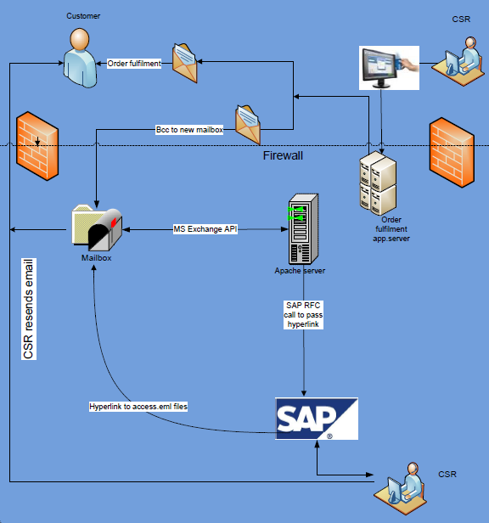

Figure 1: Project Architecture Diagram

Below is a list of process / services that are provided by SAP - Apache Mail Service.

Process Name | Process Description
MS Exchange | This service listens to the Apache dedicated Mailbox (qaemailrepos@hmhco.com) for every one minute & will retrieve all the contents of an unread email (including headers) & constructs the web URL
SAP RFC Call | Once the email has been successfully read & if it contains the order ID in the mail header then, Apache mail services generates the file name by making use of eGood Indicator & makes remote procedure call to SAP by passing order ID, file name and the constructed web URL.

MS Exchange Service

Logical Design

The logical design represents the MS Exchange Service

Apache Inbox
ThinkCentral
System
ThinkCentral system triggers an email to the Apache dedicated Mailbox (via CC)
Listen the Mailbox for every one minute

SAP - Apache
Mail Service

Retrieve all the contents of an unread email including order id which is present in the header section of the email & construct the web URL along with the file name

Web URL

Figure 2: Logical Diagram for MS Exchange Service

Physical Architecture (Topology)

The physical architecture represents the Fulfillment system touch points with SAP - Apache Mail Service for the MS Exchange Service

HMH Mail Server
ThinkCentral System

SAP - Apache
Mail Service
System : XXX.YYY.hmhco.com
IP Address : 123.45.67.890

System : XXX.YYY.hmhco.com
IP Address : 123.45.67.890

Email ID : qaemailrepos@hmhco.com
Folder : Inbox
Mail Type : Unread Mails
Listen Time : 1 Minute
Header : X-OrderNumber

Web URL :
https://owa.hmhpub.com/OWA/QAEmailrepos@hmhco.com/?ae=Item&a=Open&t=IPM.Note&id=RgAAAACVjIeqgq4wRobBlK1NRZLbBwDXMRVi7le4TLpqBjEsmjOmAAAAu%2fw3AADXMRVi7le4TLpqBjEsmjOmAAAAvK5AAAAJ&exvsurl=1

File Name :
Welcome_letter_YYYYMMDD_ HHMMSS_ <eGoodIndicator>

Web URL

Figure 3: Physical Architecture for MS Exchange Service

Event Flow

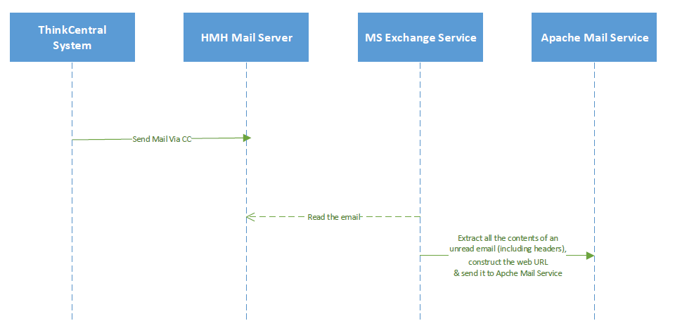

Activity Diagram
The figure below represents the process steps for MS Exchange Service.

Start
ThinkCentral system triggers an email to the Apache dedicated mail id

1
Listen the Mailbox (Inbox)
For every One Minute

2
Retrieve all the contents of an unread email along with order id & eGood Indicator which are present in the header section of the mail

3
Construct the web URL which can be used to view the mail content in web browser along with the file name

Change the status of the mail as “Read”

Figure 4: MS Exchange Service Activity Diagram
End

Configuration Details

Property | Value
Mailbox Domain Name | pubedu
Mailbox User Name | qaemailrepos
Inbox Email ID | qaemailrepos@hmhco.com
Mailbox Password | XXXXX

Key Performance Indicators / Metrics

NA

Logging and Error Handling

SAP - Apache Mail Service logs the necessary events with in its boundary into the log file. Exceptions are also logged. Below is a list of exceptions that will be handled by this process

Exception Scenario | Exception Type | Comments
Apache Mailbox is not accessible | System | SAP - Apache Mail Service will trigger an email to support team by explaining the nature of the problem & will start processing the mails once the Mailbox is accessible
Apache Mailbox password got changed | System | Mailbox related information’s are maintained in the config file. SAP - Apache Mail Service will trigger an email to support team by explaining the nature of the problem & will start processing the mails once the correct password is provided in the config file.
Order ID is not present in Incoming Mail header | System | SAP - Apache Mail Service will ignore such kind of a mails but mark the mail as “Read”
eGood Indicator is not present in Incoming Mail header | System | eGood Indicator is used to construct the file name. SAP - Apache Mail Service will considers such kind of a mails but file name won’t contain eGood Indicator value

SAP RFC Call

Logical Design

The logical design represents the SAP RFC call process.

Web URL
SAP

Once “MS Exchange Service” retrieves all the contents of an unread email including order id & eGood Indicator which is present in the header section of the email & constructs the web URL along with the file name, a SAP RFC call is made by Apache Mail Service by passing “order id, file name & web URL information”

Figure 5: Logical Diagram for SAP RFC call Process

Physical Architecture (Topology)

The physical architecture represents the SAP - Apache Mail Service touch points with SAP for the SAP RFC Call process.

SAP
SAP - Apache
Mail Service
System : XXX.YYY.hmhco.com
IP Address : 123.45.67.890

RFC Input:

- Order ID (captured in the Header section of incoming email)
- Email Web URL
- File Name

System : XXX.YYY.hmhco.com
IP Address : 123.45.67.890

Figure 6: Physical Architecture for SAP RFC Call process

Event Flow

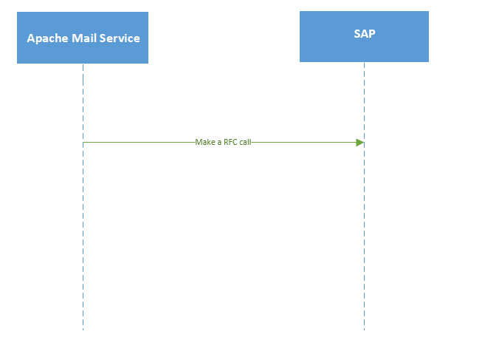

Activity Diagram
The figure below represents the process steps SAP RFC Call process.

Start
“MS Exchange Service” reads the contents of an email along with headers & constructs web URL pass it to Apache Mail Service

1
Construct the file name by making use of eGood Indicator

2
Make an RFC Call to SAP by passing
Order ID
File Name
Email Web URL

3
Process the response given by SAP

4
If the RFC call is unsuccessful then trigger an email to support team

Figure 7: SAP RFC Call Activity Diagram
End

Configuration Details

SAP RFC Name : Z_RFC_CREATE_ATTACHMENTS

SAP RFC Input & Output Parameters:
Please refer the below attached mapping sheet for the complete set of SAP RFC Input & Output Parameters

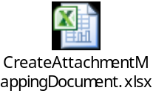

Key Performance Indicators / Metrics

NA

Logging and Error Handling

SAP - Apache Mail Service logs the necessary events with in its boundary into the log file. Exceptions are also logged. Below is a list of exceptions that will be handled by this process

Exception Scenario | Exception Type | Comments
SAP Server is Down | System | SAP - Apache Mail Service triggers an email to the support team by explaining the nature of the problem & will start processing the mails once the SAP Server is up & running.
SAP RFC Call Fails | System | SAP - Apache Mail Service triggers an email to the support team by explaining the nature of the problem & marks the mail as “Read”

Flow Chart

Refer the below PDF document for the flow chart for the SAP – Apache Mail Service



Cross Reference Details
NA

Assumptions

- SAP - Apache Mailbox Fulfilment System does not interact with Database
- SAP - Apache Mailbox Fulfilment System does not going to delete any mails from its dedicated Inbox
- SAP - Apache Mailbox Fulfilment System does not worry about the size of the incoming emails
- SAP - Apache Mailbox Fulfilment System uses the below naming convention Welcome_letter_YYYYMMDD_ HHMMSS_ <eGoodIndicator>

Issues
NA

Sign-off

Name | Role | Date | Signature
 | Spec Writer
 | Process Owner
 | Etc…

